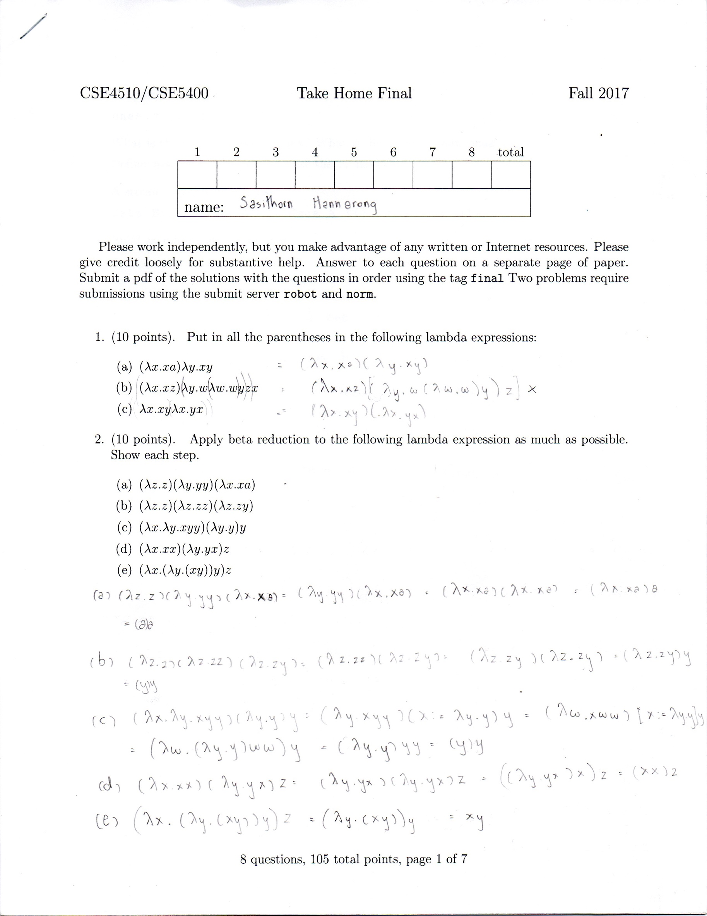

4.

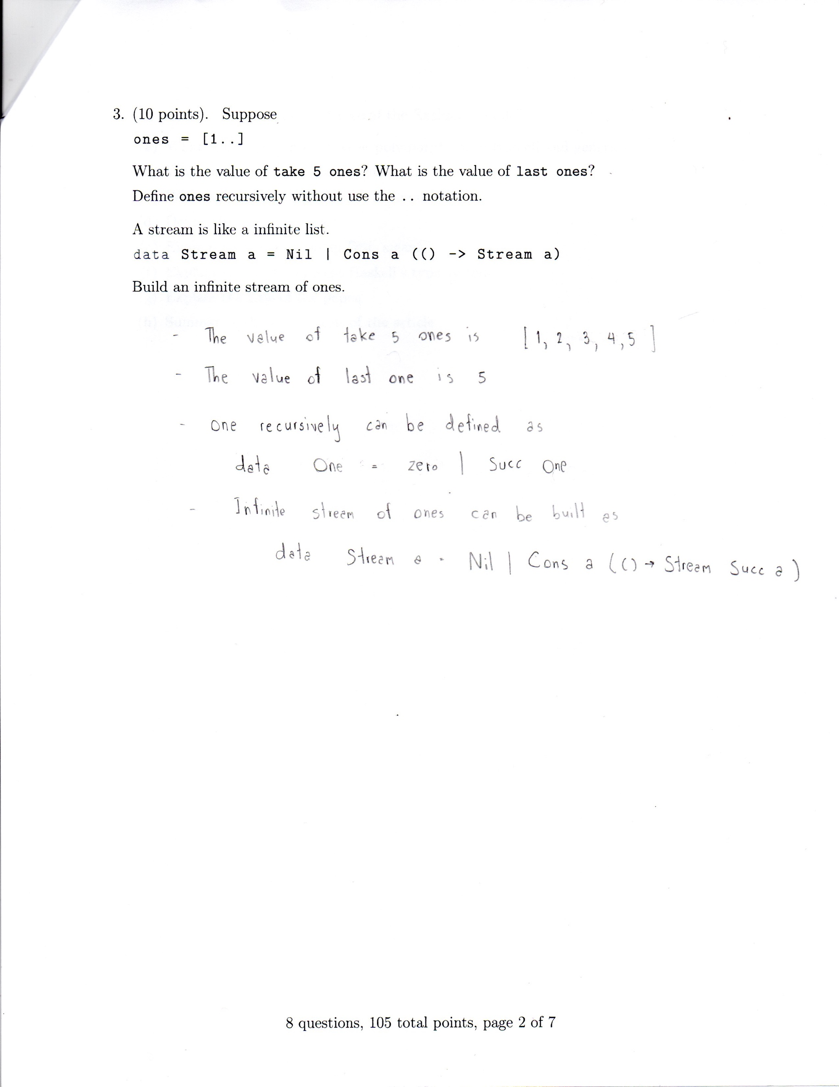

**4.(20 points) Read Meijer’s “The Curse of the Excluded Middle”**

**(a) What is big different between polymorphism in Haskell and generics in Java?**

Polymorphism in Haskell uses monads which is parameterized by a type constructor (container) while generics in Java is parameterized by a type — i.e. generics allow parameterization over List<T> and Array<T> but do not allow container type M like M<T>.

**(b) What are non-proper morphisms?**

Effect that is unique to a domain-specific operation.

**(c) What are the new “elephants” in the room**

Concurrency and parallelism

**(d) Define the word *insouciant***

*insouciant* in the paper means not obsessive- compulsive types, not function absolutely, not cover everything and still has some vulnerability behind.

**(e) Explain what the acronym DSL means**

A domain-specific language (DSL) is a computer language particular to a specific application domain and does not aim to solves problems outside its domain.

**(f) Explain how to circumvent Haskell’s type system**

Use monad and always be careful with type. Avoid impure function like unsafePerformIO.

**(g) Explain the title of the paper**

The law of excluded middle means for any proposition, either that proposition is true or its negation is true, no third answer. This paper discussing about the way to tame effects by either using purity annotations or making all effects explicit in the type system and introducing impure function such as unsafePerformIO.

**(h) Summarize the main thesis of the article**

The paper discussed about problem of taming effects in order to make an imperative language pure which is as hard and painful as making a pure language imperative. The solution is not in the middle of imperative and purity. The paper provides two ways to deal with the effects and I think the paper describes two ways to handle the effects perfectly and no need to re-summarize the idea: “either accepting that programming is ultimately about mutating state and other effects, but for pragmatic reasons tame effects as much as possible; or by abolishing all implicit imperative effects and making them fully explicit in the type system, but for pragmatic reasons allow occasional explicit effects to be suppressed.” (Meijer, 2014)

